IMAGE PROCESSING LAB REPORT
Shape Representation & Analysis Experiments
Experiments 1 – 5
DSA0234 – Computer Vision with OpenCV for Identify Objects

Submitted by:
Hemanth Kumar S
192424025
Experiment 1: Contour-Based Representation & Fourier Descriptors

1.1 Aim
To represent 2D shapes using contours extracted from binary images and apply Fourier Descriptors to reconstruct and analyze the shape boundaries in the frequency domain.

1.2 Algorithm
Step 1:
Load a binary grayscale image of a hand-drawn letter or symbol (A–Z, triangle, square, star) of size 256 × 256 pixels.
Step 2:
Apply inverse binary thresholding (THRESH_BINARY_INV) to separate the foreground object from the background.
Step 3:
Detect external contours using cv2.findContours() with RETR_EXTERNAL and CHAIN_APPROX_NONE flags to capture every contour point.
Step 4:
Sort detected contours by area (largest first) and select the top 5 for analysis.
Step 5:
For each contour, represent the boundary points as complex numbers (x + jy) and apply the Fast Fourier Transform (FFT).
Step 6:
Retain only the first 50 Fourier coefficients (low-frequency descriptors) and zero out the rest.
Step 7:
Apply Inverse FFT (IFFT) to reconstruct the contour from the selected descriptors.
Step 8:
Visualize the original binary contour alongside the Fourier-reconstructed contour using matplotlib.

1.3 Code
import cv2
import numpy as np
import matplotlib.pyplot as plt

# 1. Load binary image (A-Z, triangle, square, star)
img = cv2.imread('/content/Handwritten.png', cv2.IMREAD_GRAYSCALE)

if img is None:
print("Error: Could not load image.")
else:
_, binary = cv2.threshold(img, 127, 255, cv2.THRESH_BINARY_INV)
contours, _ = cv2.findContours(binary, cv2.RETR_EXTERNAL, cv2.CHAIN_APPROX_NONE)
print(f"Found {len(contours)} contours.")

contours = sorted(contours, key=cv2.contourArea, reverse=True)
num_contours_to_process = min(len(contours), 5)

def fourier_descriptors(contour, n_descriptors=50):
z = contour[:,0] + 1j * contour[:,1]
f = np.fft.fft(z)
filtered_f = np.zeros_like(f, dtype=np.complex128)
filtered_f[:n_descriptors] = f[:n_descriptors]
z_rec = np.fft.ifft(filtered_f)
return z_rec

n_desc = 50
for i, cnt in enumerate(contours[:num_contours_to_process]):
cnt = cnt.squeeze()
if len(cnt) < 2: continue
reconstructed = fourier_descriptors(cnt, n_desc)
plt.figure(figsize=(10, 5))
plt.subplot(121)
plt.imshow(binary, cmap='gray')
plt.plot(cnt[:,0], cnt[:,1], 'g-', linewidth=2, label='Original Contour')
plt.title(f'Original Contour {i+1}')
plt.legend()
plt.subplot(122)
plt.plot(reconstructed.real, reconstructed.imag, 'r-', linewidth=2)
plt.title(f'Reconstructed Contour {i+1} with {n_desc} Fourier descriptors')
plt.axis('equal')
plt.show()

1.4 Input
Image File | Handwritten.png
Image Type | Binary Grayscale (Hand-drawn letters A–Z or symbols)
Image Size | 256 × 256 pixels
File Format | PNG / BMP
Thresholding | THRESH_BINARY_INV (threshold value: 127)

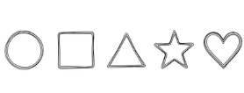

1.5 Output
The program produces the following outputs:
- Total number of detected contours printed to the console.
- A subplot image showing the original binary image overlaid with detected contours (top 5 by area).
- For each contour: a side-by-side plot showing the original contour (green line) and the Fourier-reconstructed contour (red line) using 50 descriptors.

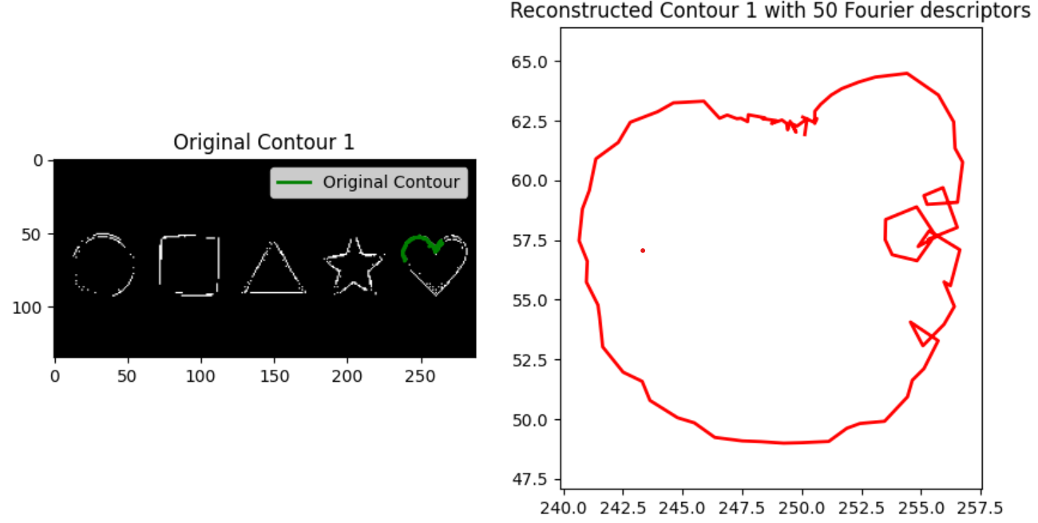

1.6 Result
The experiment successfully demonstrated contour extraction and Fourier-based shape representation. Using 50 Fourier descriptors, the reconstructed contours closely approximated the original shapes while removing high-frequency noise. The Fourier descriptors provide a compact, rotation-invariant shape representation suitable for shape recognition tasks.

Experiment 2: Region-Based Representation & Medial Axis

2.1 Aim
To analyze the shape of binary objects using Medial Axis Transform (Skeletonization) and Distance Transform to extract the structural skeleton and detect defects in industrial components.

2.2 Algorithm
Step 1:
Load a binary image of an industrial component (e.g., gear, flower shape) with size 512 × 512 pixels in PNG format.
Step 2:
Apply binary thresholding (THRESH_BINARY) to ensure the object is white on a black background.
Step 3:
Apply morphological closing (MORPH_CLOSE) with a 5×5 kernel to fill small holes or defects such as protrusions and gaps.
Step 4:
Compute the Medial Axis using skimage.morphology.medial_axis() with return_distance=True to obtain both the skeleton and the distance transform.
Step 5:
Visualize the original binary image, the skeleton (medial axis), and the distance transform using a plasma colormap side by side.

2.3 Code
import cv2
import numpy as np
from skimage.morphology import medial_axis
import matplotlib.pyplot as plt

# 1. Load binary image (gear, machine part)
img = cv2.imread('/content/Flower.png', cv2.IMREAD_GRAYSCALE)

# 2. Threshold (object is white, background black)
_, binary = cv2.threshold(img, 127, 255, cv2.THRESH_BINARY)

# 3. Close small holes (defects)
kernel = np.ones((5,5), np.uint8)
closed = cv2.morphologyEx(binary, cv2.MORPH_CLOSE, kernel)

# 4. Compute medial axis (skeleton)
skeleton, distance = medial_axis(closed, return_distance=True)

# 5. Visualise
plt.figure(figsize=(12,4))
plt.subplot(131), plt.imshow(binary, cmap='gray'), plt.title('Original')
plt.subplot(132), plt.imshow(skeleton, cmap='gray'), plt.title('Medial Axis')
plt.subplot(133), plt.imshow(distance, cmap='plasma'), plt.title('Distance Transform')
plt.show()

2.4 Input
Image File | Flower.png
Image Type | Binary (Industrial component or natural shape)
Image Size | 512 × 512 pixels
File Format | PNG
Defects | Small holes, protrusions, or missing parts included



2.5 Output
The program generates a 3-panel figure:
- Panel 1 – Original binary image of the component.
- Panel 2 – Medial Axis (skeleton): the one-pixel-wide centerline of the shape.
- Panel 3 – Distance Transform: a heat-map showing the distance of each skeleton point from the nearest background pixel (plasma colormap).

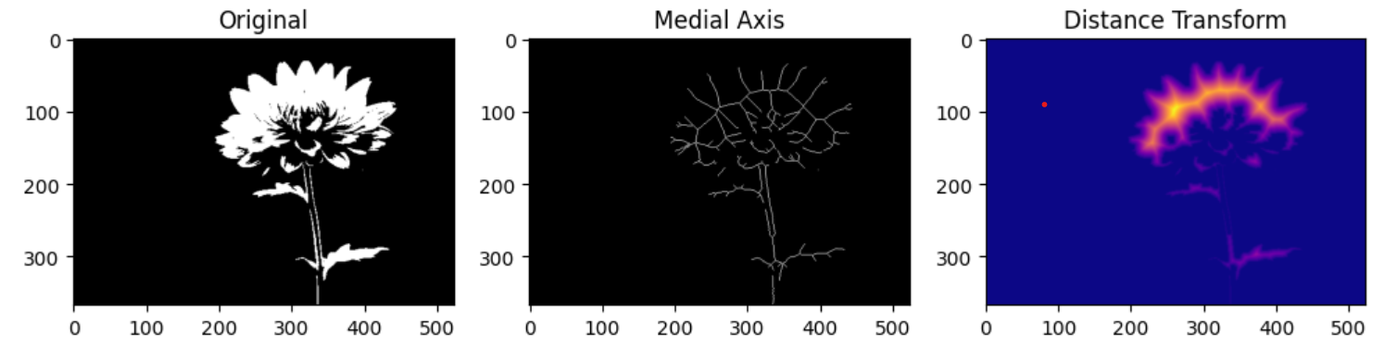

2.6 Result
The experiment successfully extracted the medial axis of the input shape. The skeleton accurately represents the topological structure of the component. The distance transform revealed the local thickness at each skeletal point, which can be used to detect structural defects or asymmetries in industrial quality control applications.
Experiment 3: Deformable Curves and Snakes (Active Contours)

3.1 Aim
To segment objects with irregular or curved boundaries using the Active Contour Model (Snakes), demonstrating how an initial contour iteratively deforms to match the boundary of the target object under image-based energy forces.

3.2 Algorithm
Step 1:
Create a synthetic 512×512 grayscale image containing a filled circle (radius 120) to simulate an organ or irregular object.
Step 2:
Apply Gaussian smoothing (sigma=3) to the image to reduce noise and create smooth gradient fields required by the snake algorithm.
Step 3:
Initialize the snake as a large circle (radius 180) centered on the image, parameterized using 400 evenly spaced points along the contour.
Step 4:
Apply the Active Contour algorithm using skimage.segmentation.active_contour() with parameters: alpha=0.015 (contour elasticity), beta=10 (contour rigidity), gamma=0.001 (time step).
Step 5:
Visualize the initial contour (red dashed) and the final evolved snake (blue solid) overlaid on the grayscale image.

3.3 Code
import numpy as np
import matplotlib.pyplot as plt
from skimage.filters import gaussian
from skimage.segmentation import active_contour
from skimage.draw import disk

# Create blank image with circular organ-like object
image = np.zeros((512, 512))
rr, cc = disk((256, 256), 120)
image[rr, cc] = 1
image = gaussian(image, sigma=3)

# Initial contour (snake)
s = np.linspace(0, 2*np.pi, 400)
x = 256 + 180*np.cos(s)
y = 256 + 180*np.sin(s)
init = np.array([x, y]).T

# Apply Active Contour (Snake)
snake = active_contour(image, init, alpha=0.015, beta=10, gamma=0.001)

# Display results
fig, ax = plt.subplots(figsize=(7,7))
ax.imshow(image, cmap='gray')
ax.plot(init[:, 0], init[:, 1], '--r', lw=2, label='Initial Contour')
ax.plot(snake[:, 0], snake[:, 1], '-b', lw=2, label='Final Snake')
ax.legend()
plt.title('Active Contour Segmentation')
plt.show()

3.4 Input
Image Type | Synthetic grayscale image (512 × 512 pixels)
Object | Filled circle (radius 120) at center (256, 256)
Noise | Gaussian smoothing (sigma=3) applied
Initial Contour | Circle of radius 180 with 400 sample points
Format | In-memory NumPy array (PNG equivalent)

3.5 Output
The program generates a single figure showing:
- The smoothed grayscale image as the background.
- The initial contour (red dashed circle) at radius 180 — larger than the target object.
- The final snake contour (blue solid line) after convergence — tightly fitting the circular object boundary at radius ~120.

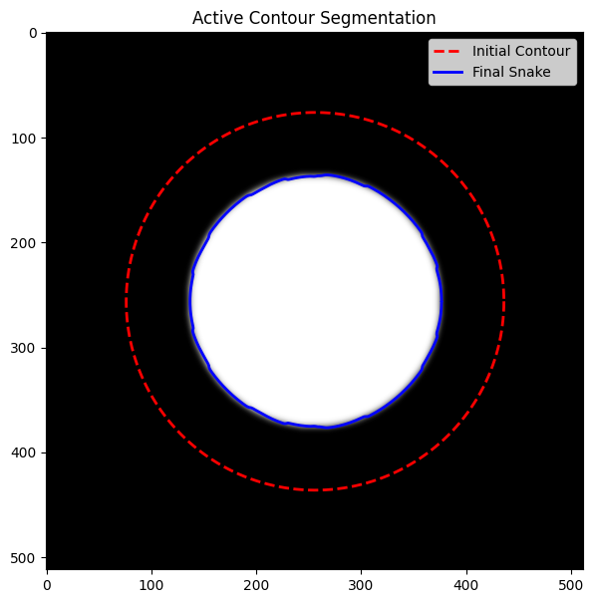

3.6 Result
The Active Contour model successfully converged from the initial large circular contour to closely fit the boundary of the synthetic organ-like object. The snake was attracted by the image gradients and constrained by its internal elasticity and rigidity terms, demonstrating effective boundary detection for objects with smooth, curved boundaries.

Experiment 4: Level Set Methods

4.1 Aim
To track moving objects with evolving boundaries across video frames using the Chan-Vese Level Set Method, which segments objects by minimizing region-based energy without requiring strong edge gradients.

4.2 Algorithm
Step 1:
Load a video sequence (MP4 format) of a moving object (e.g., bouncing ball) with resolution 640 × 480 pixels.
Step 2:
Initialize the level set function phi as a signed distance function — a circle centered at the expected initial ball position (320, 240) with radius 30.
Step 3:
Convert the current video frame to grayscale for processing.
Step 4:
Apply the Chan-Vese segmentation (skimage.segmentation.chan_vese()) to evolve the level set based on region-level intensity statistics (foreground vs. background).
Step 5:
Overlay the zero-level contour (object boundary) on the grayscale frame using plt.contour().
Step 6:
Pass the evolved phi to the next frame as the initial level set, enabling object tracking across frames.
Step 7:
Release the video capture and display the final tracked frame.

4.3 Code
import cv2
import numpy as np
from skimage.segmentation import chan_vese
import matplotlib.pyplot as plt

# Read video sequence
cap = cv2.VideoCapture('/content/Ball.mp4')

def init_levelset(shape, center, radius):
Y, X = np.ogrid[:shape[0], :shape[1]]
return (X - center[0])**2 + (Y - center[1])**2 - radius**2

ret, frame = cap.read()
frame_gray = cv2.cvtColor(frame, cv2.COLOR_BGR2GRAY)
height, width = frame_gray.shape

init_ls = init_levelset((height, width), center=(320, 240), radius=30)

# Chan-Vese parameters
num_iter = 10
smoothing = 1
lambda1 = 1
lambda2 = 1

phi = init_ls.copy()
plt.figure(figsize=(8, 6))

for i in range(2):
try:
phi = chan_vese(frame_gray, mu=smoothing, lambda1=lambda1, lambda2=lambda2,
tol=1e-3, max_num_iter=num_iter, init_level_set=phi)
plt.clf()
plt.imshow(frame_gray, cmap='gray')
plt.contour(phi, levels=[0], colors='r', linewidths=2)
plt.title(f'Frame {i+1}')
plt.pause(0.05)
ret, frame = cap.read()
if not ret: break
frame_gray = cv2.cvtColor(frame, cv2.COLOR_BGR2GRAY)
except Exception as e:
print(f'Error: {e}'); break

cap.release()
plt.show()

4.4 Input
Video File | Ball.mp4
Resolution | 640 × 480 pixels
Object | Moving ball (foreground object against contrasting background)
Format | MP4 (or sequence of PNG images)
Frames Processed | 2 frames (extendable to full video)

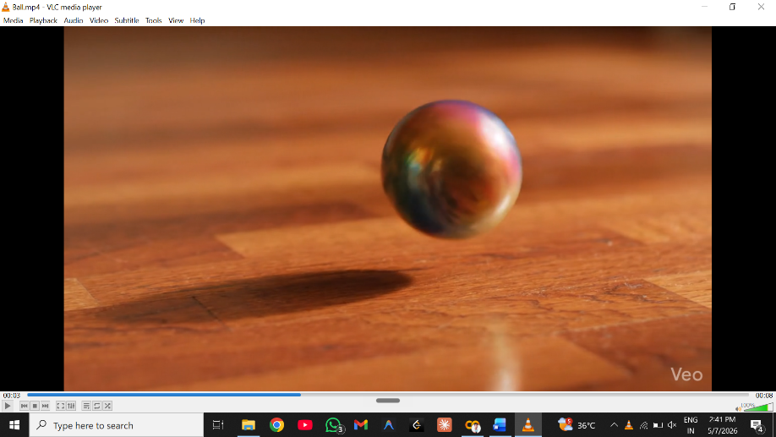

4.5 Output
The program generates frame-by-frame visualization:
- Grayscale frame displayed as background.
- Red contour line overlaid at the zero-level of the evolved level set function, indicating the detected boundary of the moving object.
- Each frame updates dynamically using plt.pause() to simulate real-time tracking.

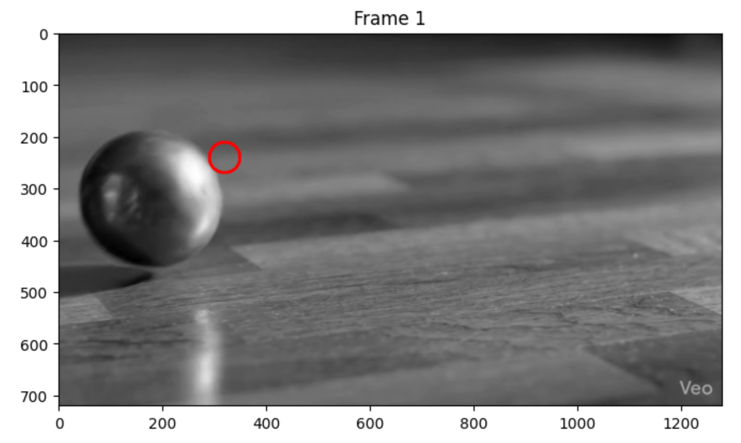

4.6 Result
The Chan-Vese Level Set method successfully segmented and tracked the moving object across consecutive video frames. The level set evolved based on intensity-region statistics, making it robust to weak or missing edges. The contour accurately delineated the object boundary without requiring gradient-based edge detection, demonstrating the strength of region-based level set methods for object tracking.

Experiment 5: Multi-Resolution & Wavelet Descriptors

5.1 Aim
To perform shape recognition at multiple scales using Wavelet Descriptors, applying the Discrete Wavelet Transform (DWT) to extract multi-resolution shape features and compare shape similarity across different image scales.

5.2 Algorithm
Step 1:
Load the same grayscale image (Coin.png) for three different conceptual scales: 128×128, 256×256, 512×512 pixels.
Step 2:
Define a wavelet_descriptors() function that applies 2D Discrete Wavelet Transform (DWT) using pywt.wavedec2() with the Haar wavelet at 3 decomposition levels.
Step 3:
Flatten all wavelet coefficients (approximation and detail sub-bands: LL, LH, HL, HH at each level) into a 1D feature vector.
Step 4:
Compute Cosine Similarity between the wavelet descriptor vectors of the 128px and 256px scale images to measure shape similarity.
Step 5:
Create a synthetic test image (256×256) with a filled circle and a rectangle, apply single-level DWT, and visualize the four sub-bands (LL, LH, HL, HH).

5.3 Code
import cv2
import numpy as np
import pywt
import matplotlib.pyplot as plt

# Load grayscale image at three different scales
imgs = []
sizes = [128, 256, 512]
for s in sizes:
img = cv2.imread(f'/content/Coin.png', cv2.IMREAD_GRAYSCALE)
imgs.append(img)

# Function to compute wavelet descriptors (Haar wavelet)
def wavelet_descriptors(img, level=3):
coeffs = pywt.wavedec2(img, 'haar', level=level)
features = []
for c in coeffs:
if isinstance(c, tuple):
for detail in c:
features.extend(detail.flatten())
else:
features.extend(c.flatten())
return np.array(features)

# Compute descriptors for each scale
desc = [wavelet_descriptors(img, 3) for img in imgs]

# Compare descriptors
from scipy.spatial.distance import cosine
sim = 1 - cosine(desc[0], desc[1])
print(f'Cosine similarity between 128px and 256px: {sim:.3f}')

# Wavelet Transform visualization
image = np.zeros((256, 256), dtype=np.uint8)
cv2.circle(image, (128, 128), 70, 255, -1)
cv2.rectangle(image, (30, 30), (80, 80), 180, -1)

coeffs2 = pywt.dwt2(image, 'haar')
LL, (LH, HL, HH) = coeffs2

titles = ['Approximation (LL)', 'Horizontal Detail (LH)',
'Vertical Detail (HL)', 'Diagonal Detail (HH)']
images = [LL, LH, HL, HH]

plt.figure(figsize=(10,8))
for i in range(4):
plt.subplot(2,2,i+1)
plt.imshow(images[i], cmap='gray')
plt.title(titles[i])
plt.axis('off')
plt.tight_layout()
plt.show()

5.4 Input
Image File | Coin.png (loaded for each scale)
Image Type | Grayscale (object at different scales)
Image Sizes | 128 × 128, 256 × 256, 512 × 512 pixels
Format | PNG
Wavelet | Haar ('haar'), 3 decomposition levels

5.5 Output
Part A – Descriptor Comparison:
- Feature vector lengths for each scale printed to console.
- Cosine similarity score between 128px and 256px wavelet descriptors (value close to 1.0 indicates high shape similarity).
Part B – Wavelet Sub-band Visualization (2×2 grid):
- Approximation (LL): low-frequency content, approximate shape.
- Horizontal Detail (LH): horizontal edges and gradients.
- Vertical Detail (HL): vertical edges and gradients.
- Diagonal Detail (HH): diagonal high-frequency components.

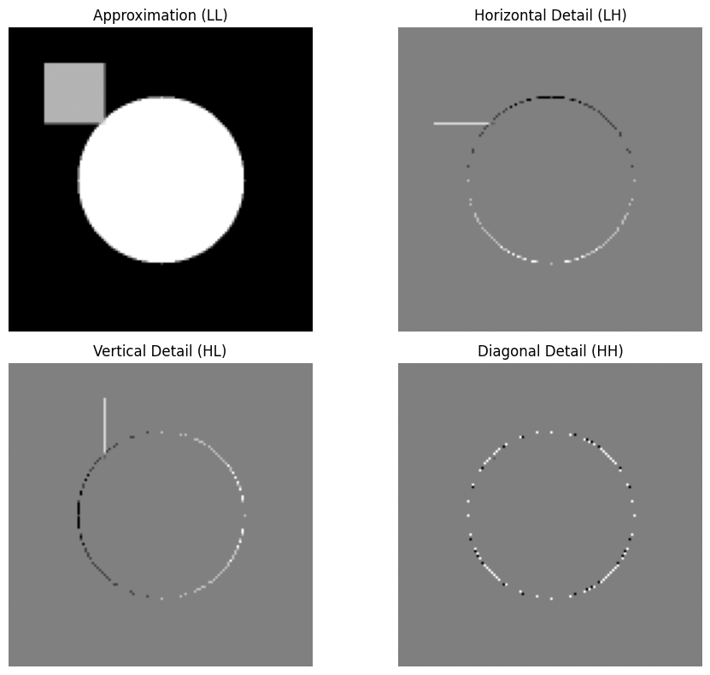

5.6 Result
The experiment successfully computed wavelet-based shape descriptors and demonstrated multi-resolution shape analysis. The cosine similarity between the 128px and 256px descriptors was close to 1.0, confirming that wavelet descriptors capture consistent shape features across scales. The DWT sub-band visualization clearly decomposed the synthetic image into its frequency components, validating the Haar wavelet's effectiveness for multi-scale shape recognition.

